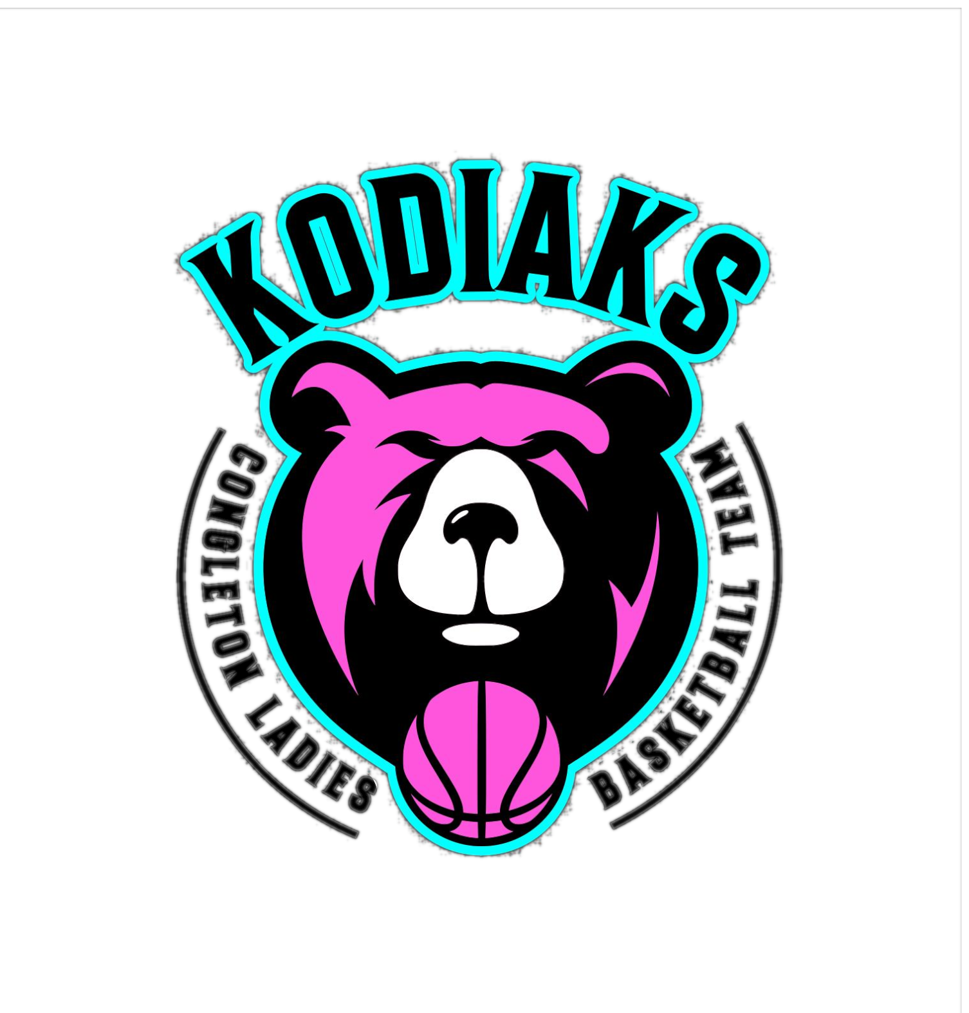
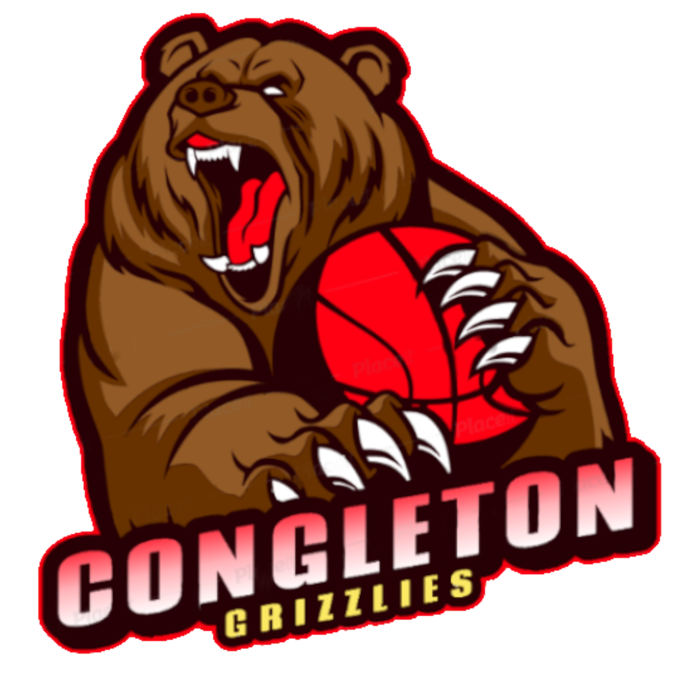
CONGLETON GRIZZLIES & KODIAKS
BASKETBALL CLUB

sPECTATOR BEHAVIOUR

Our commitment
Our club is committed to providing a safe environment for participation. Aggressive, threatening or other inappropriate behaviour by members, their families, their friends, and other sporting personnel while attending a game or event will not be tolerated.
These behaviours are outlined in our Code of Behaviour and specifically include:
- using bad language
- harassing or ridiculing players, coaches, officials or other spectators
- making racist, religious, sexist or other inappropriate comments to players, coaches, officials or other spectators
- any threatening behaviour or physical altercation between spectators and players, coaches, officials or other spectators
- putting undue pressure on children, berating them or putting down their performance
- Drinking at a game or training or being drunk at a club event.

What we will do
- Provide members, their parents and other sporting personnel with our Code of Behaviour and make clear what is expected and the consequences of non-compliance.
- Where possible, bind non-members by prominently displaying conditions of entry to grounds and facilities and by requiring parents to abide by club rules (e.g. by making parents associate members, signing our Code of Behaviour).
- Reinforce messages of fair and respectful behaviour by displaying signs and posters around our facilities and providing information on our website, in our newsletter and through other club communication.
- Encourage our coaches and officials to complete training to develop their skills and confidence.
- Ban bringing alcohol to training, a game or no-alcohol club event.
- Consult with our local police and seek their support and advice on how to handle issues involving inappropriate behaviour by spectators prior to, at or after a game.
- Encourage the reporting of incidents and investigate inappropriate behaviours as outlined in this policy and take disciplinary or whatever other actions as are deemed necessary (e.g. appoint a ground official to monitor behaviour).
- Encourage our players, coaches, officials and spectators to call the police if they are concerned about escalating behaviour and their safety or the safety of others.

What we ask you to do
- Help create a positive atmosphere for players, officials and other spectators by showing respect for players, officials and other spectators.
- Abide by our club’s Code of Behaviour and refrain from using bad language, harassing or ridiculing others or behaving in a threatening or violent manner.
- If you are aware of inappropriate spectator behaviour and you feel confident to do so, speak with the person and ask them to stop. If there is a ground official or committee member present, ask for their assistance.
- Report any inappropriate spectator behaviour to the club president or someone in a position of authority.
- Call the police or a club official if you are concerned for your safety or the safety of others.

Non-Compliance
Parents or others found to have behaved inappropriately, and who are associate members or have agreed to abide by our club's Code of Behaviour and this policy, may face disciplinary action as outlined in our Member Protection Policy.
By being present at any event/function held by Congleton Grizzlies Basketball Club, you agree to abide by this policy. Failure to do so will result in removal from the premises/event, and may lead to further consequences which include, but are not limited to:
- Barring from all club events and fixtures.
- Referral to external agencies and/or local authorities.

